

Cross Words

Monthly Newsletter of Cross Ev. Lutheran Church

March 2012 Volume 12, Issue 3

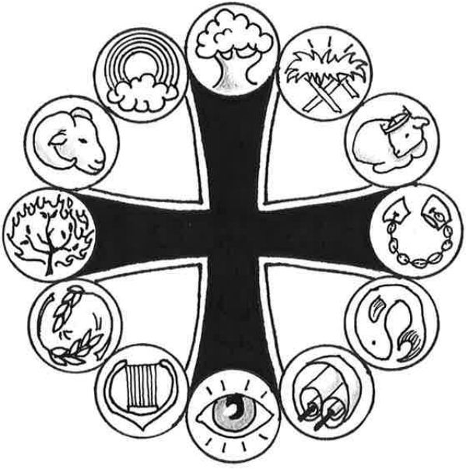

**Prominent People of the Bible**

***Abraham***

*“All peoples on earth wi****ll be blessed through you.” Genesis 12:3***

“Father Abraham had many sons / Many sons had Father Abraham / I am one of them and so are you / So let’s all praise the Lord!”

These are the words of a song often sung by children in Sunday School or at Vacation Bible School. Abraham was an Old Testament believer who received a very special promise from God. Even though he and his wife Sarah were very old and well past the age of child-bearing (at least, humanly-speaking), the Lord promised to give a son to this childless couple.

It was another 25 years – when Abraham was 100 and his wife Sarah was 90 – before the Lord’s promise was fulfilled. But then it happened. Baby boy Isaac was born! How happy Abraham and Sarah were for this precious gift of life! How wonderful to be blessed according to the Lord’s wonderful promise!

This miraculous birth serves as an amazing example of God’s gracious love. But there’s more! Not only had the Lord promised Abraham a son in his old age, he also promised that the entire world would be blessed through Abraham because of his son. Isaac was the first of many descendants from Abraham, but the greatest descendant of all was the Savior of the world, Jesus Christ!

Not only did Abraham and Sarah receive a great blessing in the birth of their son, but you and I and all people have been blessed as well, just as God had promised Abraham! We’ve been blessed through that Savior who came as one of Abraham’s descendants. He was born into this world to free us from the guilt of sin. His sacrificial death gives us eternal life with God. His great resurrection from the dead has given us ultimate victory over the grave. And now from his glorious throne in heaven, he exercises his saving will over all things. Through this descendant of Abraham, all peoples on earth have been blessed!

Because of Abraham’s connection to the Savior, Christians often refer to themselves as “children of Abraham.” Through the life and death of Jesus Christ, we’ve been brought back into God’s family. Through faith in our Savior, we are God’s blessed people – just like Abraham!

To celebrate our place in God’s family, we sing with the children: “Let’s all praise the Lord!”



**Graphic for Abraham: *Ram***

God provided a ram to be a substitute sacrifice for Isaac, Abraham's son. This life-saving substitute foreshadowed God's sacrifice of Jesus in our place.

**More information is located online at WhatAboutJesus.com. Look for the *What About … Prominent People* link.**

**Names of Wondrous Love**

**ALPHA AND OMEGA**

**He really is the First and the Last, the one and only Savior I will ever need**

In our town is a hardware store that has almost everything. When I come in looking for something for my woodworking hobby, the clerk says with a grin, “We have it all, from soup to nuts.” Sometimes, though, they don’t.

Four times the book of Revelation calls Jesus “the Alpha and the Omega.” In Revelation 22:13, Jesus himself explains what this name means: “I am the Alpha and the Omega, the First and the Last, the Beginning and the End.” Alpha and omega, you may recall, are the first and last letters in the Greek alphabet. In English we’d say, “A and Z,” or if we wanted to be colloquial, it might be “soup to nuts.”

Why is this a good name for Jesus? First of all, because he is my eternal Savior. Never before him and never after him will there be a Savior. My computer may become obsolete almost from the day I put it into use, but Jesus’ salvation is always up to date. My cell phone may quickly function like a relic, but Jesus’ salvation stays the same. He really is the First and the Last, the one and only Savior I will ever need.

Then also Jesus is the Beginning and the End. Unlike that hardware store, my Jesus does have it all. His redemptive work is all-sufficient. No updates will ever have to be downloaded to keep it current. No new and improved attachments will ever be required to bring it up to speed. “It is finished,” my Savior could say on his cross at Calvary (John 19:30). That still means sin is canceled and salvation is complete. Whether I call him Alpha and Omega or A and Z, Jesus is all I’ll ever need for my redemption.

How can I show this truth? When something is all in all for me, it’s hard not to display it. I show love for my spouse. I take care of and talk about my kids. I put myself into my work. I enjoy my hobbies. Even more so with my eternal and all-sufficient Savior. I want more and more to walk and talk like him. To live and love like him. To let everyone see how he with his wondrous love is my Alpha and Omega.

© 2011 Northwestern Publishing House. All rights reserved.

Scripture is taken from THE HOLY BIBLE, NEW INTERNATIONAL VERSION.®

**Men’s Breakfast Bible Study**

The Men’s Breakfast Bible Study will continue it’s study on *Spiritual Leadership.* This study will look at the great opportunity and priviledge God gives us to be spiritual leaders in our families and how this impacts our social and church lives.

***We will meet on Saturday, March 10 at 9:00 am this month. French Toast will be on the menu, in addition to God’s Word. Men of the congregation, this is a great chance for spiritual growth!!***

**SENIOR FELLOWSHIP**

Senior Fellowship will not have a regular meeting in March, but will chat while we are serving the Lenten Supper on March 21. All senior are invited to come an help. We will set up at 4:30 pm.

Future events will include a trip to the Old Log Theatre in May to see *A Fox in The Fairway* and a boar ride in the summer.

C:\Program Files\Microsoft Office\MEDIA\CAGCAT10\j0301480.wmf

**Men's Church Volleyball Tournament**

**MLC Gymnasium, New Ulm**

**Saturday, March 17**

**Contact Marty Bogart for Details**

**C:\Users\church office\AppData\Local\Microsoft\Windows\Temporary Internet Files\Content.IE5\QNHFUVEZ\MC900057321[1].wmf**

**ROCKFORD COMMUNITY EXPO**

**SATURDAY, MARCH 17**

**At Rockford Community Center**

**9:00AM – 1:00PM**

**HELP WITH THE CROSS BOOTH!!**

**Sign up at church**

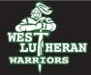

**Thursday, Mar 22, 2012**

**Time 7:30pm - 9:00pm  
Location: gym  
SACRED CONCERT**



2012 Lent & Easter Schedule

The overall theme of the Lenten worship for 2012 is ***“See His Cross!: Surprising Words From Our Savior’s Passion.”*** In this series, we receive insights into God’s plan of salvation for us as Jesus goes on his journey to the cross and to his resurrection.

*There will be a Lent Supper served before the Wednesday services for your convenience, starting at 5:30 pm. Various organizations of the congregation will be serving these suppers.*

**Mar 7 - 7:00 pm Midweek 3**

Our King Is Crucified! ..............................John 18:36,37

Pastor Paul Margrgraf

Special Music – Sunday School

**Mar 14 - 7:00 pm Midweek 4**

It’s God’s Plan From Beginning to End!...Mark 14:61,62

Special Music – Choir

**Mar 21 - 7:00 pm Midweek 5**

Glory Be to Jesus! ........................................John 17:1-5

Pastor Robert Hellmann

Special Music – Handbell Choir

**Mar 28 - 7:00 pm Midweek 6**

Shed No Tears for Jesus! ..........................Luke 23:26-31

Pastor Dennis Strong

Special Music – Ladies Choir

**Apr 5 - 7:00 pm Maundy Thursday (Lord’s Supper)**

Receive the Blessings of the Cross! ........Luke 22:19,20

Special Music – Choir

*The Handbell Choir will serve a supper on Maundy Thursday, starting at 5:30 pm, for the convenience of the worshipers)*

**Apr 6 - Good Friday – 1:00 pm (Lord’s Supper) & 7:00 pm ……………………….***“Letters To My Lord”*

**Apr 8 - Easter Sunday – 7:00 am (Sunrise Service)**

Peace and Life Are Yours!..........................John 20:19,20

***The choir will serve the annual Easter breakfast between the 2 services.***

**Apr 8 - Easter Sunday – 10:00 am (Festival Service)**



**Annual Minnesota District**

**Church Leaders Workshop**

***“Building the Leaders*** ***of our Churches***

***to Grow in*** ***Carrying out Christ’s Commission”***

***For Councilmen, Members of Boards and Committees, Called Workers, other Church Leaders, and all members interested in advancing the Kingdom of God***

***March 3, 2012***

***9 AM—2:30 PM***

***Trinity Ev. Lutheran Church***

***500 W. Church Street***

***Belle Plaine, MN 56011***

**WELS statement on health care requirements**

Rev. Mark G. Schroeder, president of the Wisconsin Evangelical Lutheran Synod, has issued the following statement regarding the U.S. Department of Health and Human Services’ new requirement that all health care plans cover contraceptives, abortive drugs, and medical procedures:

*“Recently the U.S. Department of Health and Human Services announced that it will require all health care plans, including those provided by religious organizations, to include coverage for contraceptives, abortive drugs, and medical procedures that are contrary to the doctrinal positions of many Christian churches and denominations. This action is a clear and unprecedented threat to the religious liberty guaranteed to all citizens by the First Amendment. No religious organization should be required by the government to support or facilitate activities which are in clear violation of its principles and beliefs.*

*“The Wisconsin Evangelical Lutheran Synod holds to the biblical teaching that human life begins at conception and that the unborn are fully human beings, created by God. We are deeply distressed that the government of the United States would require the health care plans of our church-affiliated organizations to provide abortion-inducing drugs or other procedures that would end the life of an unborn child and would require coverage for any other medical treatment that violates our teachings and conscience.*

*“More recently, President Obama has announced an ‘accommodation,’ saying that religious organizations will not be required to pay directly for such coverage. Instead, insurance providers serving religious organizations will be required to make these services available free of charge. As one congressman has correctly said, this is a ‘distinction without a difference,’ since such costs would still be provided indirectly by the religious organizations through the insurance premiums they pay.*

*“The Wisconsin Evangelical Lutheran Synod clearly understands and teaches that Jesus has directed his followers to ‘give to Caesar what is Caesar’s’ (*[*Mark 12:17*](http://biblia.com/bible/niv/Mark%2012.17)*) and that secular government is used by God for the good of all society. Christian citizens recognize their responsibility to pay taxes, support the government, obey its laws, and pray for its leaders. While it is not normally within the sphere of the church to become involved in secular politics, we do recognize that individual Christians have a responsibility to exercise their rights as citizens, to express their beliefs, and to encourage the government to act in the best interest of society.*

*“Therefore, we encourage all of our members, as Christian citizens, to express their convictions boldly and to urge the government to be faithful in carrying out its primary responsibility to protect and preserve life. We also encourage our members, as many others in various denominations and church bodies have done, to recognize and speak out against this clear threat to the blessing of religious liberty American citizens have enjoyed since the founding of the nation.*

*“We also confess and affirm that if the government directs us to do something in clear violation of the will of God, ‘we must obey God rather than men’ (*[*Acts 5:29*](http://biblia.com/bible/niv/Acts%205.29)*).”*

**Couples Under Christ**

**sponsors**

**Sunday, March 25, 2012**

**2:30 pm – Cost $13 per ticket**

**Timberwolves vs. Denver Nuggets**

**Concert by** *Go Fish* **after** **the game.**

**Sign Up at Church**

**Cross Lutheran Church presents**

**the annual**

Saturday, march 24

12:00 pm – 3:30 pm

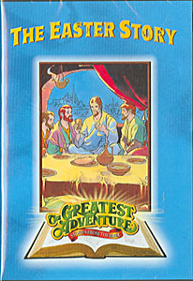

Bible lessons, arts & crafts, games

(including easter egg hunt) refreshments & movie

Preschool through 5th grade

**No charge (donations accepted)**

**To register:**

**Sign up at church**

**Or**

**Call 763-477-5981**

**Or**

**email:** [**office@crosslutheranwels.org**](mailto:office@crosslutheranwels.org)

**or**

**website: www.crosslutheranwels.org**